# Week 02: Day 03 Lab 03

## Touch-Free Switch Control Panel for Elevators

Schematic Diagram:

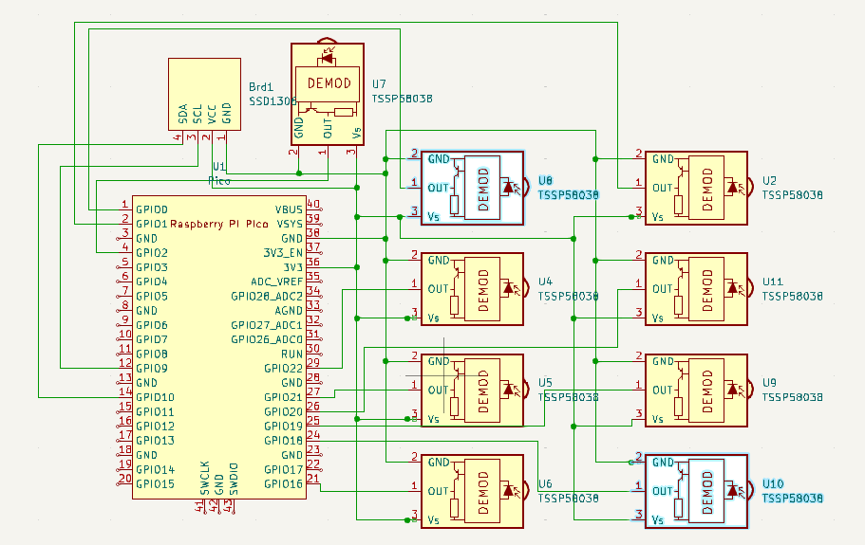

Design Rule Checker:

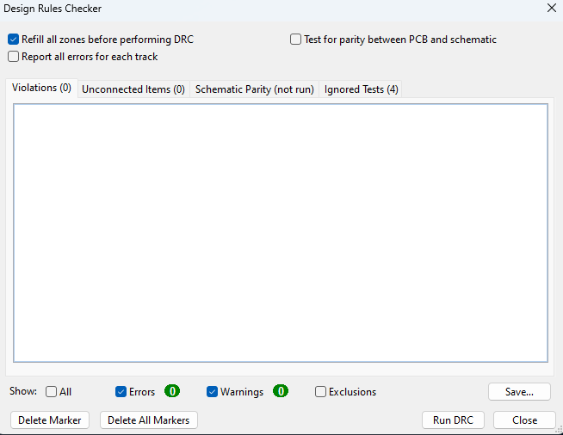

PCB Design:

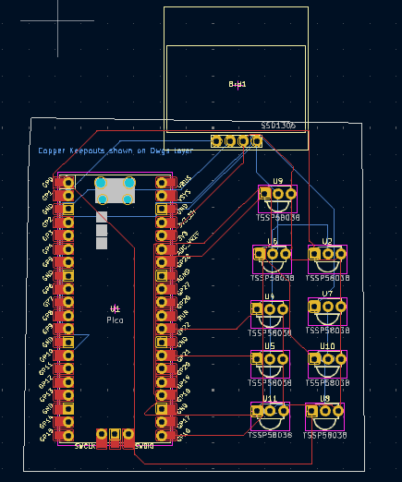

3D view:

